A CRM APPLICATION FOR THECHAISHOP&CO
User Story:
As a sales representative at TheChaiShop&Co, I need to manage customer relationships well and make the sales process smoother with our CRM app. I want to easily view and update employer information, and be able to tell online and offline customer records apart using record types so I can offer better, personalized service. I also need the app to automatically calculate sales details like order quantity and total bill amount to make sure every transaction is accurate and efficient. Plus, I would like to create clear reports and dashboards that help me understand and analyze sales data, which will support better decisions and planning. Finally, I’d like the app to send birthday emails to customers with special offers, making them feel valued and increasing their loyalty.
1. INTRODUCTION
1.1 Project Overview :
The project "A CRM Application for TheChaiShop&Co" is focused on creating a Salesforce-based Customer Relationship Management (CRM) system to handle customer, employer, and enterprise accounts effectively. The system streamlines sales processes, keeps track of customer information, produces reports, and enhances customer interaction through automated alerts. The user story and goals of the project are outlined in the beginning part of the document.
1.2 Purpose :
The goal of this project is to:
- Make managing customer relationships easier and more efficient
- Automatically handle billing and calculate order totals
- Ensure that data is accurate and reliable
- Help make better business decisions based on data
- Improve how we connect with customers by using automated emails
2. IDEATION PHASE
2.1 Problem Statement (Customer Problem Statement Template)
PS | I am  (Customer)  I’m trying | I’m trying to | But | Because | Which  makes me  feel
PS-1 | Sales  Representative | Manage  customer  orders and  billing | Calculations  are often  incorrect | Order  quantity and  billing are  manual | Stressed and  inefficient
PS-2 | Store  Manager | Monitor  sales and  customer  records | Reports are  delayed and  incomplete | Data is  stored in  multiple  files | Confused  and  dissatisfied
PS-3 | Customer | Receive  personalized  offers and  updates | I do not get  timely  notifications | There is no  automated  communicat  ion | Disconnected  and  undervalued
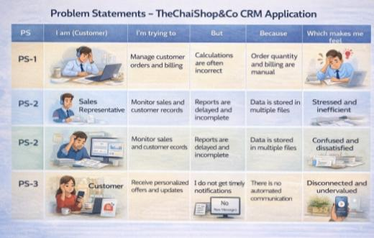

2.2 Empathy Map Canvas
Target Users
● Sales Representatives
● Managers
● System Administrators
● Business Analysts
Empathy Analysis
Aspect | Description
Think & Feel | Need accurate customer data and reports
Hear | Feedback from management
See | Multiple registers and spreadsheets
Say & Do | Enter data manually
Pain | Errors, delays, data loss
Gain | Automation, fast reports

2.3 Brainstorming
Brainstormed Ideas
● Manual CRM system
● Excel-based management
● Web-based CRM
● Salesforce-based CRM
● Automated email system
Selected Idea: Salesforce-based CRM Application for TheChaiShop&Co..
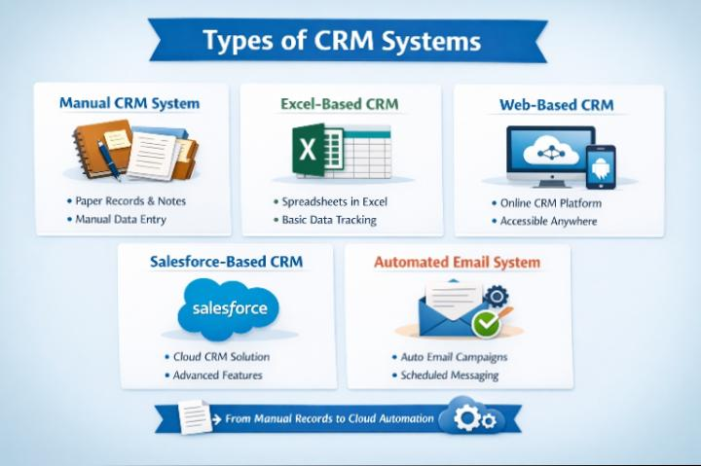

3.REQUIREMENT ANALYSIS PHASE
3.1 Customer Journey Map
Journey Stages:
● Login
● Access CRM Application
● Enter Customer Data
● Generate Orders
● Calculate Bills
● View Reports
● Dec 3.2 Solution Requirements
Functional Requirementsision Making
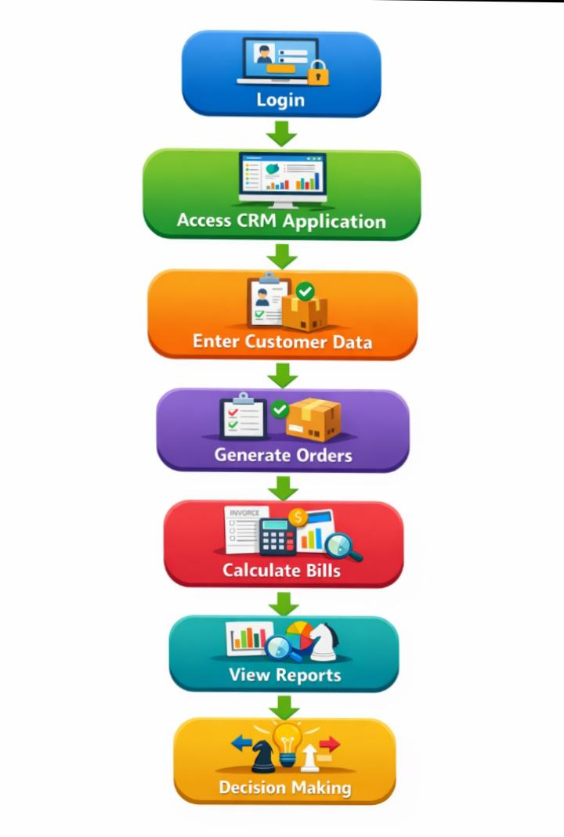
3.2 Solution Requirements
Functional Requirements
FR No | Requirement
FR-1 | User Login
FR-2 | Object Creation
FR-3 | Data Entry
FR-4 | Billing Automation
FR-5 | Report Generation
FR-6 | Email Automation

Non-Functional Requirements
NFR-1: Usability
The system is designed to be user-friendly so that sales representatives, managers, administrators, and analysts can easily use it without needing any technical knowledge or special training.
Requirements :
- A simple and easy-to-use interface for users
- Well-organized navigation menus for smooth access
- Forms that are clear and easy for users to understand and fill out
- Interactive and user-friendly dashboards for better data viewing
Example:
A newly joined sales employee should be able to quickly log into the system, add customer information, and create orders within a short time without needing assistance.
The Salesforce Lightning interface supports this by offering drag-and-drop functionality and simple, easy-to-use navigation.
NFR-2: Security
The system should ensure that customer and business information is securely protected from any unauthorized access.
Requirement:
• Access permissions based on user roles
• Safe user authentication during login
• Data stored using encryption for security
• Regular data backup and recovery mechanisms.
Example:
• User access manages and security
• Security controls applied at both object and field levels
• Limited access to billing-related information
• Strong authentication methods and strict password guidelines
NFR-3: Reliability
The CRM system must function reliably at all times and ensure that all information is stored accurately without any data loss.
Requirements:
• Automatic storage of data
• Periodic system backup procedures
• Mechanisms for detecting and managing system errors
• A reliable and secure cloud environment
Examples:
When a user enters order information and the network disconnects, the system must preserve the entered data and restore it later. Salesforce Cloud helps ensure this through automatic backup services.
NFR-4: Performance
Requirements:
• Rapid page loading speed
• Fast creation of reports
• Efficient and seamless dashboard display
• Very little response delay
Examples:
If a manager generates a monthly sales report for hundreds of customers, the system should display the report within a few seconds. Performance can be enhanced through query optimization and caching.
NFR-5: Availability
The system should be available for access whenever needed.
Requirements:
• Continuous system operation throughout the day (24/7)•
• Very limited system interruption
• Hosting through cloud infrastructure
• Procedures for disaster recovery
Example:
Managers should have the ability to use the CRM system at any time, including busy business hours, weekends, or late at night. Salesforce Cloud offers high system availability.
NFR-6: Scalability
The system must be capable of handling business expansion without reducing its performance.
Requirements:
• Capability to support a growing number of users
• Ability to manage increasing volumes of customer information
• Flexible and scalable storage capacity
• Consistent system performance and speed
Example: If The Chai Shop & Co expands to several branches, the CRM system must be capable of managing a large number of customers without reducing performance. The Salesforce platform is designed with scalable infrastructure, allowing it to automatically adjust and handle increasing customer data and users efficiently.
3.3 Data Flow Diagram
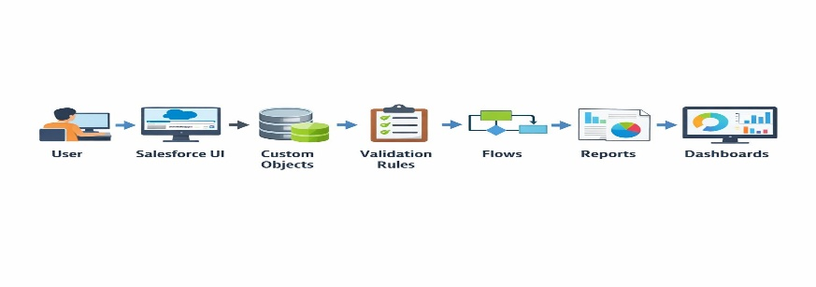
User → Salesforce UI → Custom Objects → Validation Rules → Flows → Reports →Dashboards.

3.4 Technology Stack

Layer | Technology
Frontend | Salesforce Lightning
Database | Salesforce Cloud
Automation | Flows
Backend | Salesforce Platform
Analytics | Reports & Dashboards

4. PROJECT DESIGN PHASE
4.1 Problem–Solution Fit
The CRM system improves business operations by replacing manual record keeping with automated data handling. Information is securely stored in the cloud, which reduces the risk of data loss. Interactive dashboards help users analyze data more effectively, while real-time reports provide quick access to important information. This allows businesses to generate accurate insights and make timely decisions.
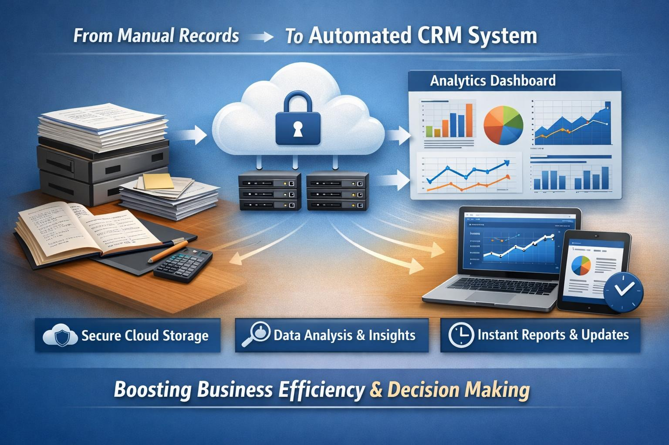

4.2 Proposed Solution
Functional Requirements

Parameter | Description
User Login & Authentication | Allows authorized users to securely log in to the CRM system  using valid credentials.
Customer Record  Management | Enables users to create, view, update, and delete customer details  such as name, contact number, and address.
Employer &  Enterprise  Management | Allows management of employer and enterprise account  information for business operations.
Order Management | Supports creation and tracking of customer orders, including  order quantity and product details.
Automated Billing  System | Automatically calculates total bill amount using formula fields  based on order quantity and pricing.
Validation Rules | Ensures accurate data entry by validating fields such as phone  number, PAN, and Aadhaar.
Record Types &  Page Layouts | Provides different record types and layouts for various customer  and enterprise categories
Global Picklists | Maintains standardized values for fields such as product type,  category, and status.
Email Notification  System | Sends automated emails to customers for birthdays, offers, and  order confirmations.
Workflow & Flow  Automation | Automates tasks such as updating records and triggering alerts  using Salesforce Flows.
Report Generation | Generates detailed reports on sales, customers, and enterprise  performance.
Dashboard  Visualization | Displays real-time analytics through interactive dashboards and  charts.
Data Backup &  Recovery | Ensures secure storage and recovery of business data in the  Salesforce cloud.
User Role  Management | Controls system access using profiles and permission sets for  different users.

4.3 Solution Architecture
Architecture Layers
1. Presentation Layer – Lightning UI
2. Application Layer – Flows and Logic
3. Data Layer – Custom Objects
4. Analytics Layer – Reports and Dashboards
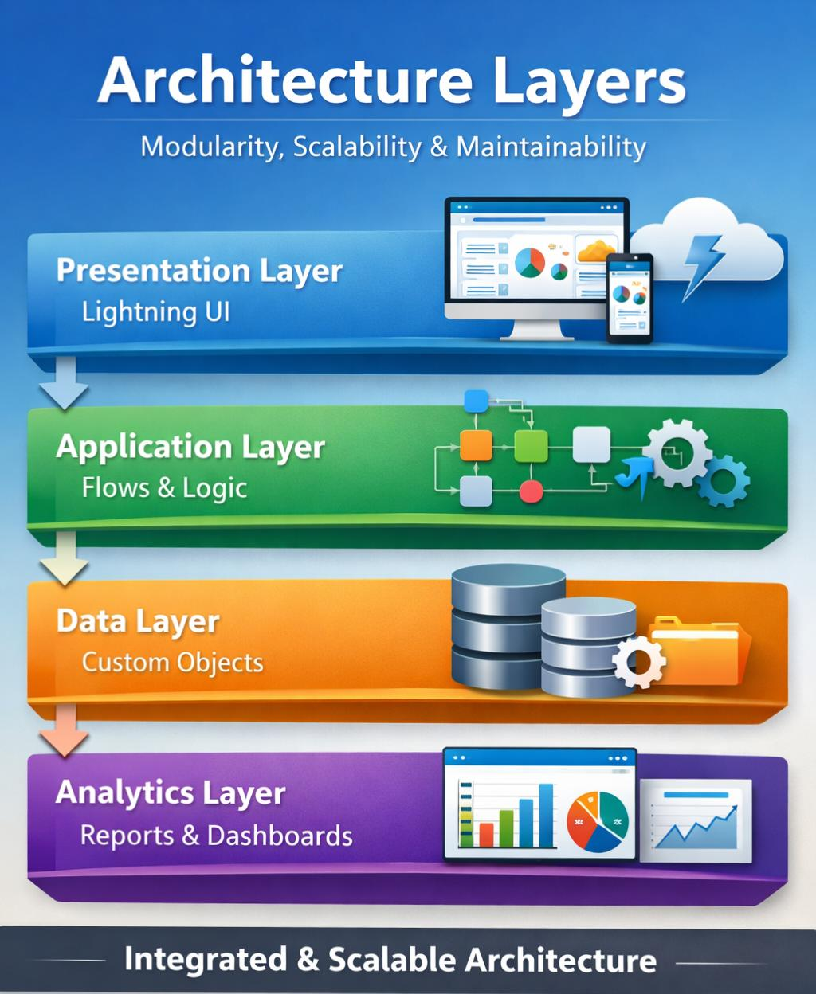
This layered architecture ensures modularity, scalability, and maintainability.

5. PROJECT PLANNING & SCHEDULING
5.1 Project Planning
● The project followed an Agile-based development approach with defined
milestones and sprints.
● A Salesforce Developer account was created to set up the development
environment.
● Custom objects were designed to store customer, employer, and enterprise data.
● Custom tabs and a Lightning Application were developed for easy system
navigation.
● Fields, relationships, and global picklists were configured to ensure data
consistency.
● Page layouts and record types were created based on user roles and customer
categories.
● Validation rules were implemented to prevent incorrect data entry.
● Email templates and automated flows were developed for customer notifications.
● Reports and dashboards were created for performance monitoring and analysis.
● Regular sprint reviews and testing were conducted to track progress and resolve
issues.
● The project was completed within the planned timeline through systematic
scheduling.
Product Backlog, Sprint Schedule, and Estimation (4 Marks)
Use the below template to create product backlog and sprint schedule

Sprint | Functional  Requirement  (Epic) | User  Story  Number | User Story / Task | Story  Points | Priority | Team members
Sprint-1 | Developer  Setup | USN-1 | As a manager, I want a dedicated  Lightning App so that all CRM  operations are accessible from a  single dashboard. | 1 | High | Member1
Sprint -1 | Data Modeling | USN-2 | As an admin, I want to create  customer and order fields so that  complete sales and billing details  can be captured accurately. | 3 | High | Member2
Sprint -2 | Data Modeling | USN-3 | As a user, I want customized page  layouts for different record types so  that only relevant information is  displayed during data entry | 3 | High | Member3
Sprint -2 | Data Modeling | USN-4 | As a manager, I want a dedicated  Lightning App so that all CRM  operations are accessible from a  single dashboard. | 3 | High | Member4
Sprint -2 | Data Modeling | USN-5 | As an admin, I want to create  customer and order fields so that  complete sales and billing details  can be captured accurately. | 5 | Medium | Member1
Sprint -2 | Data Modeling | USN-6 | As a user, I want customized page  layouts for different record types so  that only relevant information is  displayed during data entry | 5 | High | Member2
Sprint -2 | Data Modeling | USN-7 | As a manager, I want separate  record types for Retail and  Enterprise customers so that  different business categories can  be managed efficiently. | 5 | Medium | Member3
Sprint -3 | Automation | USN-8 | As a system, I want to validate  customer details and order inputs  so that incorrect data entries are  prevented. | 3 | High | Member4
Sprint -3 | Automation | USN-9 | As a system, I want automated  flows to send email notifications so  that customers receive timely  updates and offers. | 5 | High | Member1
Sprint -4 | Automation | USN-10 | As a system, I want to  automatically calculate billing  amounts so that invoices are  generated without manual effort | 5 | High | Member2
Sprint -5 | Reports | USN-11 | As a manager, I want sales and  customer reports so that I can  monitor business performance and  make informed decisions. | 4 | High | Member3
Sprint -6 | Dashboards | USN-12 | As a manager, I want visual  dashboards so that I can quickly  analyze sales, customers, and  enterprise performance. | 4 | Medium | Member4

6. Project Development Phase:
Project Flow
Milestone 1 : Creation of developer account
Milestone 2 : Object Creation
Milestone 3 : Tabs
Milestone 4 : The Lightning App
Milestone 5 : Global Picklist
Milestone 6 : Fields and Relationships
Milestone 7 : Creation of Page Layout
Milestone 8 : Creation of Record Types
Milestone 9 : Validation rules
Milestone 10 : Email Templates
Milestone 11 : Flows
Milestone 12 : Reports and Dashboards
Milestone 13 : Conclusion
What you'll learn
- Real Time Salesforce Project
- Standard and Custom objects
3. Picklist Value sets
4. . Types of Fields & their relationships.
5. Page Layouts
6. Record Types
7. Validation Rules
8. Email Templates
9. Flows
10. Reports and Dashboards.

Implementation
Milestone 1 - Salesforce developer account creation :
Activity 1: Creating Developer Account:
Creating a developer org in salesforce.
- Go to https://developer.salesforce.com/signup
- On the sign up form, enter the following details :

1) First name & Last name
2) Email
3) Role : Developer
4) Company : College or Company Name
5) County : India
6) Postal Code : pin code
7) Username : should be a combination of your name and company
This need not be an actual email id, you can give anything in that format :
username@organization.com

Click on sign me up after filling these.
Activity 2: Account Activation :
1. Go to the inbox of the email that you used while signing up. Click on the verify
account to activate your account.
2. Click the Object Manager tab. If you don’t see it, enter Object Manager in
the Quick Find box
3. On the Object Manager page, click Create | Custom Object.
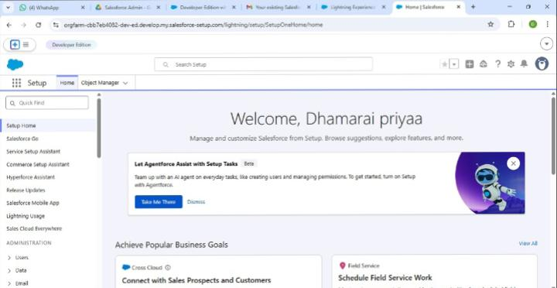
4. Then you will redirect to your salesforce setup page.
Milestone 2 - Objects
1. In your Salesforce org, click gear icon on the top left and select Setup to
open Setup.
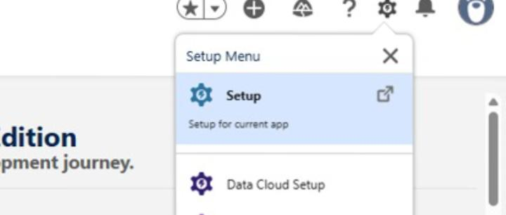
2. Click the Object Manager tab. If you don’t see it, enter Object Manager in
the Quick Find box.
3. On the Object Manager page, click Create | Custom Object.
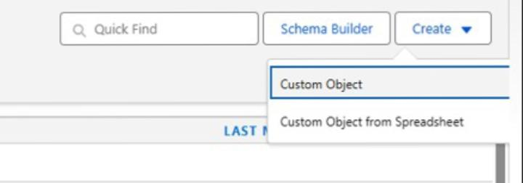

Activity 1 : Employer Account Object
1. From the setup page → Click on Object Manager → Click on Create → Click on
Custom Object.
● Label : Employer Account
● Plural Label : Employer Accounts
● Enter Record Name Label and Format
Record Name : Employer Account Name
Data Type : Text
● In Optional features : check the boxes for Allow Reports | Allow Activities
| Track Field History.
● Search Status : check the box for Allow Search.
● Save
Activity 2 : Customer Account Object
1. From the setup page → Click on Object Manager → Click on Create → Click on
Custom Object.
● Label : Customer Account
● Plural Label : Customer Accounts
● Enter Record Name Label and Format
Record Name : Customer Account Name
Data Type : Text
● In Optional features : check the boxes for Allow Reports | Allow Activities
| Track Field History.
● Search Status : check the box for Allow Search.
● Save
Activity 3 : Enterprise Account Object
1. From the setup page → Click on Object Manager → Click on Create → Click on
Custom Object.
● Label : Enterprise Account
● Plural Label : Enterprise Accounts
● Enter Record Name Label and Format
Record Name : Enterprise Account Name
Data Type : Text
● In Optional features : check the boxes for Allow Reports | Allow Activities
| Track Field History.
● Search Status : check the box for Allow Search.
● Save
Milestone 3 - Tabs
Activity 1 : Custom tabs creation
1. Go to setup page → type Tabs in Quick Find bar → click on tabs → New
(under custom object tab)

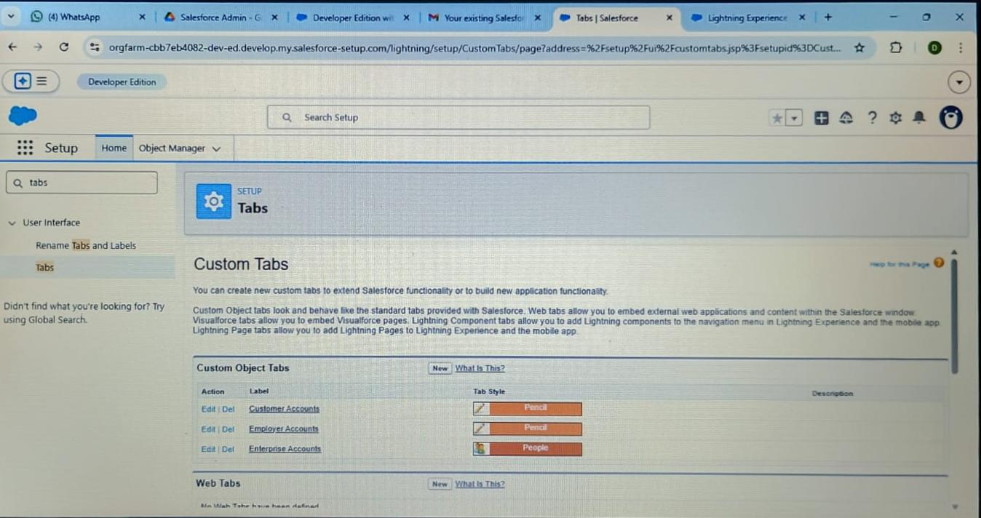

- Select Object(Employer Accounts) → Select the tab style → Next (Add to
Profiles page) keep it as default → Next (Add to Custom App) uncheck
The include tab .
- Make sure that the Append tab to users’ existing personal customization
Is checked.

- Click save.
- Repeat the same steps for Customer Accounts and Enterprise Accounts.
Milestone 4 – The Lightning App
Activity 1 : Create a lightning app
- Go to setup page → search “app manager” in quick find → select “app manager”
→ click on New lightning App.

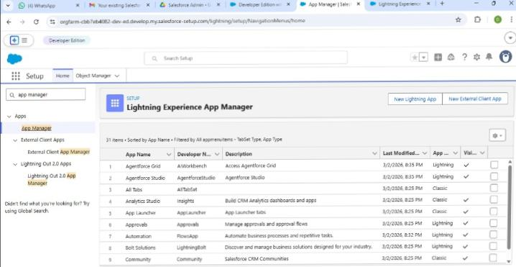
- Fill the app name in app details and branding as follow
App Name : TheChaiShop&Co
Developer Name : Auto Populates
Add image optional (if you want to give any image you can otherwise not
Mandatory) – Add Primary color Hex or leave it to default.
Then click Next.
- In App options
Navigation style : Standard navigation
Setup experience : setup
Supporters form factors : Desktop and phone
Then click Next
- In Utility items
Utility Bar alignment : Default
Then click Next.
- Navigation items
Select the created Custom Objects and required standard objects
● Customer Accounts
Employer Accounts
Enterprise Accounts
Reports
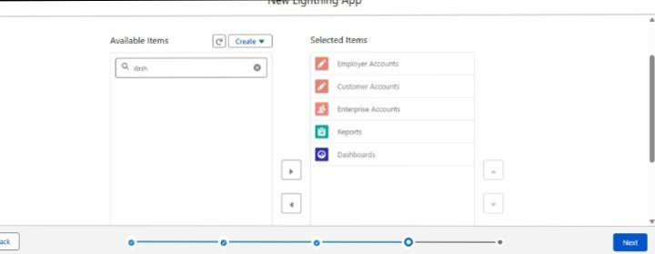
Dashboards
- To Add User Profiles : System Administrator
- Click Save & Finish.
Milestone 5 : Global Picklist
Activity 1 : Create Global Picklist
- In Quick find box search for : Picklist value sets and click New.
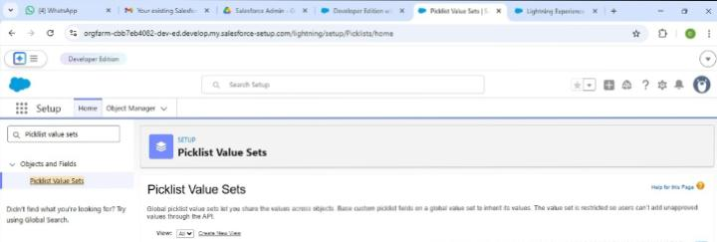
● Label : Gender
Name : Auto Populates
Values : Male
Female
Others
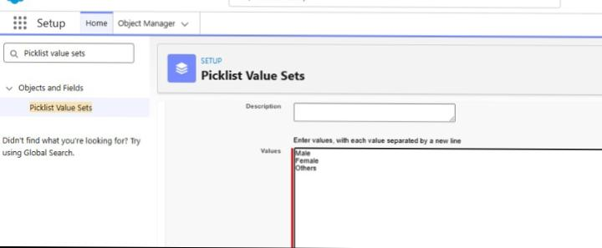
Click Save & New.
2. Create three more Global picklists following the same steps.
● Label : Items
Name : Auto populates
Values : Platinum Tea Powder
Double Delight Tea Powder
Super Dust Tea Powder
Osmania Biscuits (Value Pack)
Osmania Biscuits (Premium Pack)
Dry Fruit Biscuits
Fruit Biscuit
Salt Biscuits
Multigrain Biscuits
Ragi Biscuits
Double Choco Chip Cookies
Butter Almond Cookies
Melting Moments Cookies
Honey Oats Cookies
Delight Box
Signature Box
Assorted Box
Click Save & New.
● Label : Payment Mode
Name : Auto populates
Values : Gpay
PhonePe
Paytm
Credit or Debit card
Cash.
Click Save & New.
● Label : Type of Items
Name : Auto populates
Values : Tea powder
Cookies
Gift Hampers
Click Save.
Milestone 6 : Fields & Relationships
Activity 1 : Create Custom fields for Employer Account
- In your Salesforce org, click gear icon on the top left and select Setup to open
Setup.
- Click the Object Manager tab. If you don’t see it, enter Object Manager in the
Quick Find box.
- From the object manager page, In the Quick Find box, Search for the custom
Object you just created : Employer Account
- From the sidebar, click Fields & Relationships. Notice that there are already
Some fields there. Those are the standard fields.
- Click New to create a custom field. Tip: Before creating a new field, do a quick
Search to make sure a similar one doesn’t already exist
- Next, choose a data type as Text. Choosing a data type helps you format the field
Input.
- Click on next.
8.Data Type : Text
Field Label: First Name
Field Name : Auto Populates
Length : 25
Required : Check the box
Click on Next → Next → Save and new.
9. Repeat the Same steps for remaining fields
● Data Type : Text
Field Label: Last Name
Field Name : Auto Populates
Length : 25
Required : Check the box
Click on Next → Next → Save and new.
● Data Type : PickList
Field Label: Gender
Values : Use Global Picklist value set and
Select Gender from the dropdown menu.
Field Name : Auto Populates.
Required : Check the box
Click on Next → Next → Save and new.
● Data Type : Phone
Field Label : Phone Number
Field Name : Auto Populates
Required : Check the box
Click on Next → Next → Save and new.
● Data Type : Email
Field Label : Email ID
Field Name : Auto Populates
Required : Check the box
Click on Next → Next → Save and new.
● Data Type : Date
Field Label : Date of Birth
Field Name : Auto Populates
Required : check the box
Click on Next → Next → Save and new.
● Data Type : Text
Field Label : Aadhar Number
Field Name : Auto Populates
Length : 12
Click on Next → Next → Save and new.
● Data Type : Text
Field Label : PAN Details
Field Name : PAN_Details
Length : 10
Click on Next → Next → Save and new.
● Data Type : Picklist
Field Label : Designation
Field Name : Auto Populates
Value : Enter value, with each value separated by a new line.
Manager
Finance and Accounting
Kitchen Staff
Cashier
Servers
Click on Next → Next → Save and new.
● Data Type : Currency
Field Label : Salary
Field Name : Auto Populates
Click on Next → Next → Save.
Activity 2: Create Custom fields for Customer Account
1. Data Type : Text
Field Label: First Name
Field Name : Auto Populates
Length : 25
Required : Check the box
Click on Next → Next → Save and new.
2. Data Type : Text
Field Label: Last Name
Field Name : Auto Populates
Length : 25
Required : Check the box
Click on Next → Next → Save and new.
3. Data Type : PickList
Field Label: Gender
Values : Use Global Picklist value set and
select Gender from the dropdown menu.
Field Name : Auto Populates.
Required : Check the box
Click on Next → Next → Save and new.
4. Data Type : Phone
Field Label : Phone Number
Field Name : Auto Populates
Required : Check the box
Click on Next → Next → Save and new.
5. Data Type : Date
Field Label : Date of Birth
Field Name : Auto Populates
Required : check the box
Click on Next → Next → Save and new.
6. Data Type : Formula
Field Label : Date of Birthday is today ?
Field Name : Auto Populates
Formula Return : Checkbox
Formula :
IF(
AND(
DAY( TODAY() ) = DAY( Date_of_Birth__c ) ,
MONTH ( TODAY()) = MONTH( Date_of_Birth__c )),
TRUE,
FALSE)
Click on Next → Next → Save and new.
7. Data Type : Email
Field Label : Email ID
Field Name : Auto Populates
Required : Check the box
Click on Next → Next → Save and new.
8. Date Type : Text
Field Label : Address
Field Name : Auto Populates
Length : 125
Click on Next → Next → Save and new.
9. Date Type : Multi Select Picklist
Field Label : Type of Items
Values : Use Global Picklist value set and
select Type of Items from the dropdown menu.
Field Name : Auto Populates.
Required : Check the box
Click on Next → Next → Save and new.
10.Date Type : Multi Select Picklist
Field Label : Products purchased
Values : Use Global Picklist value set and
select Items from the dropdown menu.
Field Name : Auto Populates.
Required : Check the box
Click on Next → Next → Save and new.
11. Date Type : Multi Select Picklist
Field Label : Chai
Value : Enter value, with each value separated by a new line.
TheChaiShop&Co Special Tea
Single Tea
Masala Tea
Lemon Tea
Ginger Tea
Green Tea
Sugar Free Tea
Click on Next → Next → Save and new.
12. Data Type : Picklist
Field Label : Payment Mode
Values : Use Global Picklist value set and
select Payment Mode from the dropdown menu.
Field Name : Auto Populates.
Required : Check the box
Click on Next → Next → Save and new.
13. Data Type : Lookup Relationship
Related To : Employer Account
Field Label : Associated Employer
Field Name : Auto Populates
Click on Next → Next → Save and new.
14. Data Type : Formula
Field Label : Order Quantity
Field Name : Auto Populates
Formula Return : Number
Enter Formula = Quantity (Number) =
IF(INCLUDES( Products_Purchased__c , "Platinum Tea Powder"), 1, 0 ) +
IF(INCLUDES( Products_Purchased__c , "Double Delight Tea Powder"), 1, 0 ) +
IF( INCLUDES( Products_Purchased__c , "Super Dust Tea Powder") , 1, 0) +
IF(INCLUDES( Products_Purchased__c , "Osmania Biscuits (Value Pack)"), 1, 0 ) +
IF(INCLUDES( Products_Purchased__c , "Osmania Biscuits (Premium Pack)"), 1, 0 ) +
IF( INCLUDES( Products_Purchased__c , "Dry Fruit Biscuits") , 1, 0) +
IF(INCLUDES( Products_Purchased__c , "Fruit Biscuits"), 1, 0 ) +
IF(INCLUDES( Products_Purchased__c , "Salt Biscuits"), 1, 0 ) +
IF(INCLUDES( Products_Purchased__c , "Multigrain Biscuits"), 1, 0 ) +
IF(INCLUDES( Products_Purchased__c , "Ragi Biscuits"), 1, 0 ) +
IF( INCLUDES( Products_Purchased__c ,"Double Choco chip Cookies") , 1, 0) +
IF(INCLUDES( Products_Purchased__c , "Butter Almond Cookies"), 1, 0 ) +
IF(INCLUDES( Products_Purchased__c , "Melting Moments Cookies"), 1, 0 ) +
IF( INCLUDES( Products_Purchased__c , "Honey Oats Cookies") , 1, 0) +
IF(INCLUDES( Products_Purchased__c , "Delight Box"), 1, 0 ) +
IF(INCLUDES( Products_Purchased__c , "Signature Box"), 1, 0 ) +
IF( INCLUDES( Products_Purchased__c , "Assorted Pack") , 1, 0) +
IF(INCLUDES( Chai__c , "TheChaiShop&Co Special Tea"), 1, 0) +
IF(INCLUDES( Chai__c , "Single Tea"), 1, 0) +
IF(INCLUDES( Chai__c , "Masala Tea"), 1, 0) +
IF(INCLUDES( Chai__c , "Lemon Tea"), 1, 0) +
IF(INCLUDES( Chai__c , "Ginger Tea"), 1, 0) +
IF(INCLUDES( Chai__c , "Green Tea"), 1, 0) +
IF(INCLUDES( Chai__c , "Sugar Free Tea"), 1, 0)
Click on Next → Next → Save and new.
15. Data Type : Formula
Field Label : Total Bill
Field Name : Auto Populates
Formula Return : Number
Enter Formula = Quantity (Number) =
IF(INCLUDES( Products_Purchased__c , "Platinum Tea Powder"), 175, 0 ) +
IF(INCLUDES( Products_Purchased__c , "Double Delight Tea Powder"), 150, 0 ) +
IF( INCLUDES( Products_Purchased__c , "Super Dust Tea Powder") , 125, 0) +
IF(INCLUDES( Products_Purchased__c , "Osmania Biscuits (Value Pack)"), 50, 0 ) +
IF(INCLUDES( Products_Purchased__c , "Osmania Biscuits (Premium Pack)"), 80, 0 ) +
IF( INCLUDES( Products_Purchased__c , "Dry Fruit Biscuits") , 110, 0) +
IF(INCLUDES( Products_Purchased__c , "Fruit Biscuits"), 160, 0 ) +
IF(INCLUDES( Products_Purchased__c , "Salt Biscuits"), 110, 0 ) +
IF(INCLUDES( Products_Purchased__c , "Multigrain Biscuits"), 170, 0 ) +
IF(INCLUDES( Products_Purchased__c , "Ragi Biscuits"), 190, 0 ) +
IF( INCLUDES( Products_Purchased__c ,"Double Choco chip Cookies") , 200, 0) +
IF(INCLUDES( Products_Purchased__c , "Butter Almond Cookies"), 110, 0 ) +
IF(INCLUDES( Products_Purchased__c , "Melting Moments Cookies"), 150, 0 ) +
IF( INCLUDES( Products_Purchased__c , "Honey Oats Cookies") , 160, 0) +
IF(INCLUDES( Products_Purchased__c , "Delight Box"), 850, 0 ) +
IF(INCLUDES( Products_Purchased__c , "Signature Box"), 1500, 0 ) +
IF( INCLUDES( Products_Purchased__c , "Assorted Pack") , 600, 0) +
IF(INCLUDES( Chai__c , "TheChaiShop&Co Special Tea"), 70, 0) +
IF(INCLUDES( Chai__c , "Single Tea"), 50, 0) +
IF(INCLUDES( Chai__c , "Masala Tea"), 60, 0) +
IF(INCLUDES( Chai__c , "Lemon Tea"), 40, 0) +
IF(INCLUDES( Chai__c , "Ginger Tea"),55, 0) +
IF(INCLUDES( Chai__c , "Green Tea"), 45, 0) +
IF(INCLUDES( Chai__c , "Sugar Free Tea"), 55, 0)
Click on Next → Next → Save.
Activity 3: Create Custom fields for Enterprise Account
1. Data Type : Text
Field Label: Enterprise Name
Field Name : Auto Populates
Length : 25
Required : Check the box
Click on Next → Next → Save and new.
2. Data Type : Phone
Field Label : Phone Number
Field Name : Auto Populates
Required : Check the box
Click on Next → Next → Save and new.
3. Data Type : Email
Field Label : Email ID
Field Name : Auto Populates
Required : Check the box
Click on Next → Next → Save and new.
4. Date Type : Text
Field Label : Address
Field Name : Auto Populates
Length : 125
Click on Next → Next → Save and new.
5. Date Type : Multi Select Picklist
Field Label : Type of Items
Values : Use Global Picklist value set and
select Type of Items from the dropdown menu.
Field Name : Auto Populates.
Required : Check the box
Click on Next → Next → Save and new.
6. Date Type : Multi Select Picklist
Field Label : Products purchased
Values : Use Global Picklist value set and
select Items from the dropdown menu.
Field Name : Auto Populates.
Required : Check the box
Click on Next → Next → Save and new.
7. Data Type : Lookup Relationship
Related To : Employer Account
Field Label : Associated Employer
Field Name : Auto Populates
Click on Next → Next → Save and new.
8. Data Type : Formula
Field Label : Order Quantity
Field Name : Auto Populates
Formula Return : Number
Enter Formula = Quantity (Number) =
IF(INCLUDES( Products_Purchased__c , "Platinum Tea Powder"), 1, 0 ) +
IF(INCLUDES( Products_Purchased__c , "Double Delight Tea Powder"), 1, 0 ) +
IF( INCLUDES( Products_Purchased__c , "Super Dust Tea Powder") , 1, 0) +
IF(INCLUDES( Products_Purchased__c , "Osmania Biscuits (Value Pack)"), 1, 0 ) +
IF(INCLUDES( Products_Purchased__c , "Osmania Biscuits (Premium Pack)"), 1, 0 ) +
IF( INCLUDES( Products_Purchased__c , "Dry Fruit Biscuits") , 1, 0) +
IF(INCLUDES( Products_Purchased__c , "Fruit Biscuits"), 1, 0 ) +
IF(INCLUDES( Products_Purchased__c , "Salt Biscuits"), 1, 0 ) +
IF(INCLUDES( Products_Purchased__c , "Multigrain Biscuits"), 1, 0 ) +
IF(INCLUDES( Products_Purchased__c , "Ragi Biscuits"), 1, 0 ) +
IF( INCLUDES( Products_Purchased__c ,"Double Choco chip Cookies") , 1, 0) +
IF(INCLUDES( Products_Purchased__c , "Butter Almond Cookies"), 1, 0 ) +
IF(INCLUDES( Products_Purchased__c , "Melting Moments Cookies"), 1, 0 ) +
IF( INCLUDES( Products_Purchased__c , "Honey Oats Cookies") , 1, 0) +
IF(INCLUDES( Products_Purchased__c , "Delight Box"), 1, 0 ) +
IF(INCLUDES( Products_Purchased__c , "Signature Box"), 1, 0 ) +
IF( INCLUDES( Products_Purchased__c , "Assorted Pack") , 1, 0)
Click on Next → Next → Save and new.
9. Data Type : Formula
Field Label : Total Bill
Field Name : Auto Populates
Formula Return : Number
Enter Formula = Quantity (Number) =
IF(INCLUDES( Products_Purchased__c , "Platinum Tea Powder"), 175, 0 ) +
IF(INCLUDES( Products_Purchased__c , "Double Delight Tea Powder"), 150, 0 ) +
IF( INCLUDES( Products_Purchased__c , "Super Dust Tea Powder") , 125, 0) +
IF(INCLUDES( Products_Purchased__c , "Osmania Biscuits (Value Pack)"), 50, 0 ) +
IF(INCLUDES( Products_Purchased__c , "Osmania Biscuits (Premium Pack)"), 80, 0 ) +
IF( INCLUDES( Products_Purchased__c , "Dry Fruit Biscuits") , 110, 0) +
IF(INCLUDES( Products_Purchased__c , "Fruit Biscuits"), 160, 0 ) +
IF(INCLUDES( Products_Purchased__c , "Salt Biscuits"), 110, 0 ) +
IF(INCLUDES( Products_Purchased__c , "Multigrain Biscuits"), 170, 0 ) +
IF(INCLUDES( Products_Purchased__c , "Ragi Biscuits"), 190, 0 ) +
IF( INCLUDES( Products_Purchased__c ,"Double Choco chip Cookies") , 200, 0) +
IF(INCLUDES( Products_Purchased__c , "Butter Almond Cookies"), 110, 0 ) +
IF(INCLUDES( Products_Purchased__c , "Melting Moments Cookies"), 150, 0 ) +
IF( INCLUDES( Products_Purchased__c , "Honey Oats Cookies") , 160, 0) +
IF(INCLUDES( Products_Purchased__c , "Delight Box"), 850, 0 ) +
IF(INCLUDES( Products_Purchased__c , "Signature Box"), 1500, 0 ) +
IF( INCLUDES( Products_Purchased__c , "Assorted Pack") , 600, 0)
10.Data Type : Picklist
Field Label : Payment Mode
Values : Use Global Picklist value set and
select Payment Mode from the dropdown menu.
Field Name : Auto Populates.
Required : Check the box
Click on Next → Next → Save.
Milestone 7 : Page Layouts
For the personalized field view in Customer Accounts, let's create two page layouts
Online orders and Walk-In orders.
Activity 1: Online Orders page layout
1. Go to the setup page → click on object manager → From drop down click edit for
Customer Account object.
- Click on the Page Layouts → click New.
- Page Layout Name : Online Orders and click Save
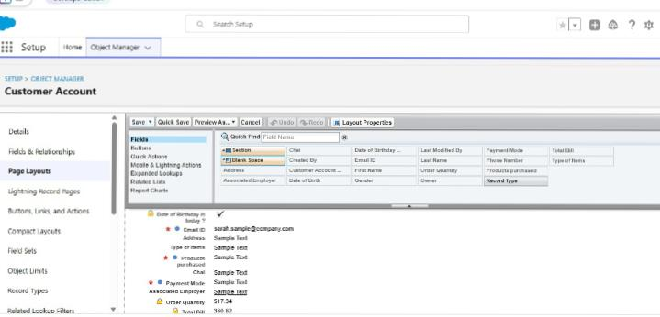
- Drag and Arrange all the required fields as shown below

. 5. Click Save.
Activity 2: Walk-In Orders page layout
1. Go to the setup page → click on object manager → From drop down click edit for
Customer Account object.
2. Click on the Page Layouts → click New.
3. Page Layout Name : Walk-In orders and click save.
4. Drag and Arrange all the required fields as shown below.
5. Click Save.

Milestone 8 - Record Types
To Differentiate the records and data stored in Customer Accounts, let's create two
different Record Types.
Online orders and Walk-In orders.
Activity 1: Online Orders Record Type
1. Go to the setup page in → click on object manager → From drop down click edit for
Customer Account object.
- Click on the Record Types → click New
3. Enter Details :
Existing Record Type : Master
Record Type Label : Online Order
Record Type Name : Auto Populates
Active : Tick the checkbox
Click Next
4. In Assign Page Layouts
● Select Apply one layout to all profiles : select Online orders from the drop
down menu.
Drag and Arrange all the required fields as shown below
Click Save.
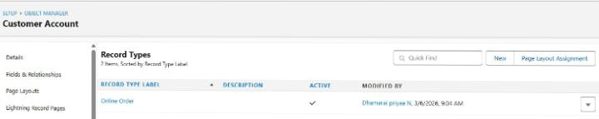

Activity 2: Walk-In Orders Record Type
1. Go to the setup page → click on object manager → From drop down click edit for
Customer Account object.
2. Click on the Record Types → click New.
3. Enter Details :
Existing Record Type : Master
Record Type Label : Walk-In Order
Record Type Name : Auto Populates
Active : Tick the checkbox
Click Next
- In Assign Page Layouts

● Select Apply one layout to all profiles : select Walk-In orders from the
drop down menu.
- Click Save.
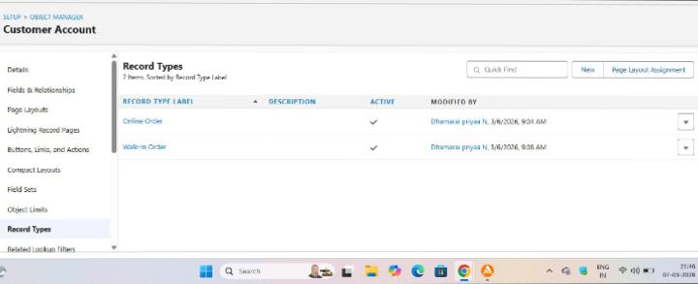
Milestone 9 - Validation Rules
Activity 1: On Employer Account
1. Go to the setup page → click on object manager → From drop down click edit for
Employer Account object.
2. Click on the validation rule → click New.
3. Enter Rule Name : Aadhar Number
Error Condition Formula :
AND(
NOT(ISBLANK( Aadhar_Number__c )),
LEN( Aadhar_Number__c ) <> 12,
NOT(REGEX( Aadhar_Number__c , "^[1-9]{12}$"))
)

4. Error Message : Aadhar number is required.
The Aadhar number must be 12 digits long.
Aadhar number can only contain numeric digits.
Aadhar number never starts with 0
5. Click Save & New.
6. Repeat the same steps and create two more validation rules on the employer
account object.
● Enter Rule Name : PAN Number
Error Condition Formula :
AND(
NOT(ISBLANK( Phone_Number__c )),
NOT(REGEX( Phone_Number__c , "^[1-9]{10}$")),
NOT(REGEX( Phone_Number__c , "^\\d+$"))
)
Error Message : The PAN Details field must not be blank.
The PAN card number does not start with 0.
The PAN card number does not contain special characters.
Click Save & New.
● Enter Rule Name : Phone Number
Error Condition Formula :
AND(
NOT(ISBLANK( Phone_Number__c )),
NOT(REGEX( Phone_Number__c , "^[1-9]{10}$")),
NOT(REGEX( Phone_Number__c , "^\\d+$"))
)
Error Message :
The phone number field must not be blank.
The phone number must consist of exactly 10 digits.
The phone number must contain only numeric digits
(no spaces, dashes, parentheses, etc.)
Click Save.
Activity 2: On Customer Account
1. Go to the setup page → click on object manager → From drop down click edit for
Customer Account object.
2. Click on the validation rule → click New.
3. Enter Rule Name : Phone Number
Error Condition Formula :
AND(
NOT(ISBLANK( Phone_Number__c )),
NOT(REGEX( Phone_Number__c , "^[1-9]{10}$")),
NOT(REGEX( Phone_Number__c , "^\\d+$"))
)
Error Message :
The phone number field must not be blank.
The phone number must consist of exactly 10 digits.
The phone number must contain only numeric digits
(no spaces, dashes, parentheses, etc.)
4. Click Save.
Activity 3: On Enterprise Account
1. Go to the setup page → click on object manager → From drop down click edit for
Customer Account object.
2. Click on the validation rule → click New.
3. Enter Rule Name : Phone Number
Error Condition Formula :
AND(
NOT(ISBLANK( Phone_Number__c )),
NOT(REGEX( Phone_Number__c , "^[1-9]{10}$")),
NOT(REGEX( Phone_Number__c , "^\\d+$"))
)
Error Message :
The phone number field must not be blank.
The phone number must consist of exactly 10 digits.
The phone number must contain only numeric digits
(no spaces, dashes, parentheses, etc.)
- Click Save.
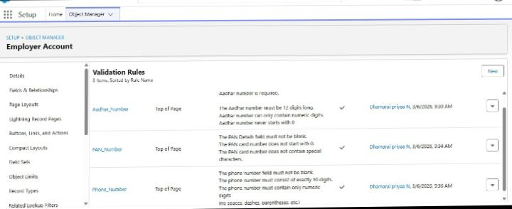

Milestone 10 - Email Template
Activity 1: Email Template
1. Go to setup, In quick find box enter Email template → click on classic Email
Template.
2. Click on→ New Email Template
3. Choose the type of email template you would like to create : Text and click Next.

● Available Merge Fields
Select Field Type : Customer Accounts Fields
Select Field : First Name
Copy Merge Field value : Auto Populates, Copy the value and paste it in
the email body where required.
4. Folder : Unfiled public Classic Email templates
5. Click on available for use
6. Email Template Name is “Birthday Offer Email”
7. Template Unique Name : Auto populated
8. Subject : Special Birthday Offer Inside!
9. Email body :
Dear {!Customer_Account__c.First_Name__c},
Happy Birthday from all of us at TheChaiShop&Co! 🎉🎂 We hope your special day is filled with joy,
laughter, and wonderful memories.
To celebrate your birthday, we have a special gift just for you! As a token of our appreciation for your
continued support, we're delighted to offer you an exclusive birthday discount.
🎁 Birthday Offer: Enjoy a fantastic 50% off on your next purchase as our birthday gift to you!
This offer is our way of saying thank you for being a valued customer. Simply use the code
[HBDAY50] at checkout to redeem your birthday treat.
We hope this special offer adds a little extra sparkle to your birthday celebrations!
Once again, happy birthday! Thank you for choosing TheChaiShop&Co! and being part of our
community.
Warm regards
TheChaiShop&Co!
10.Click Save.
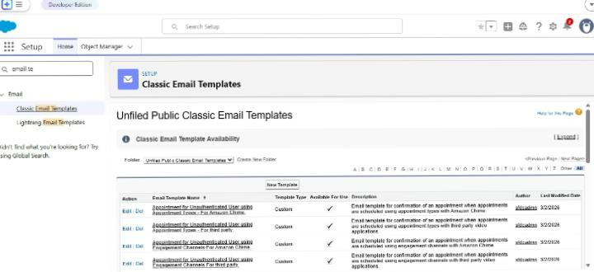
Activity 2: Email Alert
1. Go to setup, In quick find box enter Email Alert → click on Email Alert .
2. Click on New Email Alert.
3. Description : Happy Birthday email alert
Unique Name : Auto Populates
Object : Customer Account
Email Template : Search for Birthday Offer Email
Recipient Type : Search : Email field : Email ID
From Email Address : Default Workflow user’s email address
Click Save.
Milestone 11 - Flows
Let’s create a scheduled Triggered flow to automate the Birthday offer mails.
Activity 1: Schedule Triggered Flow
1. Go to setup, Type Flow in quick find box → Click on the Flow and Select the
New Flow.
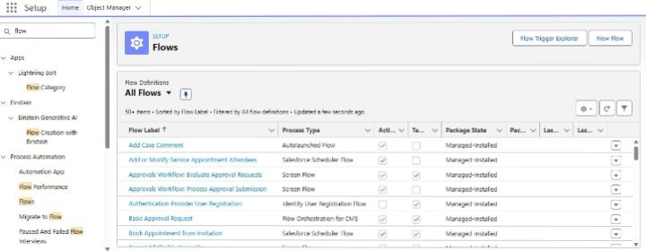
- Select Schedule - Triggered Flow and click Create.
3. Set a Schedule
Start Date : Enter the Date, when you want to start the flow.
Start Time : Enter the Time, when you want to start the flow.
Frequency : Daily
4. Create Object
Object : Customer Account
Condition Requirements : All conditions Are Met (AND)
● Field : Date_of_Birthday_is_today__c
Operator : Equals
Value : $GlobalConstant.True
● Field : Email_ID_c
Operator : IS NULL
Value : $GlobalConstant.False
5. Click (+) Icon on the flow builder and Select Action Component.
6. In New Action Page
Filter By : Type and select Email Alert
In Action : Search and select Happy Birthday email alert
Label : Send Happy Birthday Email
API Name : Auto Populates
Set Input Values for the Selected Action : Record ID : {!$Record.Id}
7. Click Done.
8. Click Save on the top right
Flow Label : Happy Birthday Email Flow
Flow API Name : Auto Populates
Click Save
- Click Activate.
Milestone 12 - Reports & Dashboards
Activity 1: Customer Account Sales Report
1. Click App Launcher and select TheChaiShop&Co.
2. Click Reports
3. Click New Repory
4. In search type Customer Accounts and Select Customer Accounts.
5. Click Start Report.
6. Click the toggle Update Preview Automatically to ON.
7. Drag and Drop all the required Columns from the Outline pane.
8. Group Rows : Search and Select
Customer Account: Record Type
9. Click Add Chart on the top
10.Click Save on the top right.
Enter
Report Name: Customer Account Sales Report
Report Unique Name : Auto Populates
Click Save.
Activity 2: Enterprise Account Sales Report
1. Repeat the same steps to create another report.
2. Click Reports
3. Click New Report
4. In search type Enterprise Accounts and Select Enterprise Accounts.
5. Click Start Report.
6. Click the toggle Update Preview Automatically to ON.
Drag and Drop all the required Columns from the Outline pane.
Group Rows : Search and Select
Type of Items.
7.Click Add Chart on the top.
8. Click Save on the top right.
a. Enter
b. Report Name : Enterprise Account Sales Report
c. Report Unique Name : Auto Populates
d. Click Save.

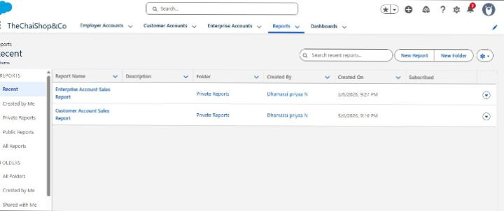

Activity 3: Dashboard
1. Click Dashboards
2. Click New Dashboard
3. Name : Customer Vs Enterprise Sales
4. Click Create.
5. Click Widget
6. Select Chart or Table.
7.Select Customer Account Sales Report
8. Display As : Select the one which you feel comfortable with.
9. Click Add
10. Repeat the same steps for the Enterprise Account Sales Report.
11. Click Save.

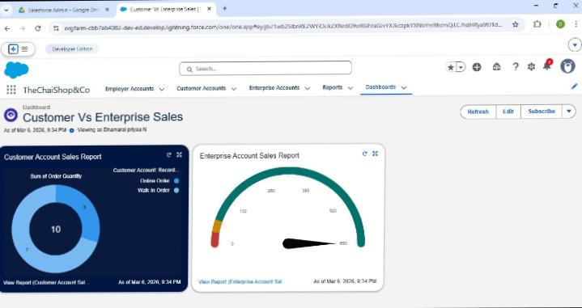

Milestone 12 – Conclusion
The development of the TheChaiShop&Co CRM application represents an important step toward improving the store’s business operations and customer relationship management. The system effectively combines employee details, customer data from both online and offline sources, and business information into a single platform, making daily operations more organized and efficient. By automating tasks such as calculating order quantities and generating total bill amounts, the application minimizes human errors and allows staff to focus more on providing quality service to customers. In addition, the system automatically sends birthday email greetings to customers, helping the business maintain personalized communication and strengthen customer relationships.

7.FUNCTIONAL & PERFORMANCE TESTING
During the testing stage, screenshots were taken from the Salesforce Lightning interface to confirm that the system was functioning properly. The testing process covered several areas, including the creation of records for Employer, Customer, and Enterprise objects. It also involved checking validation rules for Aadhar numbers, PAN details, and phone numbers to ensure correct data entry. Record types and page layouts were reviewed to confirm that information was displayed correctly. Formula fields used for calculating order quantities and total billing amounts were tested for accuracy. In addition, the flow responsible for sending birthday email notifications to customers was executed and verified. Reports and dashboards were also generated to ensure that data could be analyzed effectively. Performance testing confirmed that the system responds quickly and operates smoothly during usage.
8. ADVANTAGES & DISADVANTAGES
Advantages
● Centralized data management
● Reduced manual work
● Automated calculations
● Improved customer engagement
● Real-time analytics
Disadvantages
. ● Requires Salesforce license
. ● Internet dependency
● Limited offline access
9. Conclusion:

The CRM system designed for TheChaiShop&Co helps improve business operations by organizing customer information in one place, automating billing activities, and generating useful reports. This system reduces manual mistakes, saves time, and makes daily tasks more efficient. By using automation and data insights, the application also helps the business maintain better relationships with customers and supports effective decision-making.
10.APPENDIX
Source Code : Salesforce Configuration & Flows
Dataset : Customer and Sales Records
Tools Used : Salesforce Developer Org

Thank you

